**DBMS ASSIGNMENT**

Assignment 1:

**Problem Statement:**

Suppose you are given the following requirements for creating a simple database for the I-league, the National level football tournament in India:

* The I-league has many teams,
* Each team has a name, a city, a coach, a captain, and a set of players,
* Each player belongs to only one team,
* Each player has a name, a position (such as left wing or goalie), a skill level, and a set of injury records,
* A team captain is also a player,
* A game is played between two teams (referred to as host team and guest team) and has a date (such as May 11th, 1999) and a score (such as 4 to 2).

**Requirement Analysis:**

* System will show the details of the matches played in a specific date.
* System will provide the names of players played for a team in a particular match.
* A user can see the statistical analysis of scored goals of a team.
* System will provide the name of the venue where a particular match was held.
* System will show the name of the coach coaches for a team.
* System can show how experienced a coach is.
* A user can view how experienced a referee is.
* A user also can view how experienced a manager is.
* A user can view the positions of players in a team in a particular match.

**Entity-Relationship Data Model:**

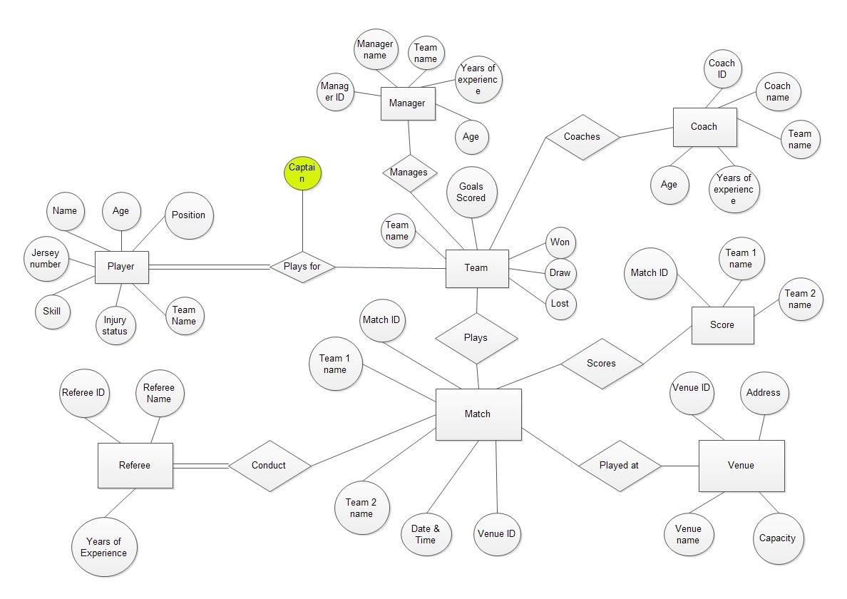

**Relational Schema:**

* **Player**(Name, Age, Position, Jersey Number, Skill, Injury Status, Team Name)
* **Team**(Team Name, Goal Scored, Won, Draw, Lost)
* **Manager**(Manager ID, Manager Name, Team Name, Years Of Experience, Age)
* **Coach**(Coach ID, Coach Name, Team Name, Years Of Experience, Age)
* **Score**(Match ID, Team 1 Name, Team 2 Name)
* **Venue**(Venue ID, Address, Venue Name, Capacity)
* **Match**(Match ID, Team 1 Name, Team 2 Name, Date & Time, Venue ID)
* **Referee**(Referee ID, Referee Name, Years of Experience)

Assignment 2:

**Problem Statement:**

**Restaurant Management System**

The restaurant maintains Catalogue for the list of food and beverage items that it provides. A part from providing food facility at their own premises at the restaurant takes order online through their System. Orders on phone are also entertained. To deliver the delivers we have delivery boys. Each delivery boy is assigned to specific area code. The delivery boy can’t delivery outside the area which is not assigned to delivery boy (for every delivery boy there can be single area assigned to that delivery boy). Customers’ record is maintained so that premium customer can be awarded discount.

**Requirement Analysis:**

* System will generate restaurant sales reports which provide an overview of all transactions completed during a selected time period.
* System will show the areas covered by the restaurant for delivering order.
* System will show the number of customers ordered in a particular day.
* System will generate a menu reports which automatically track menu sales and shows us exactly how the menu items are affecting the sales.

**Entity-Relationship Data Model:**

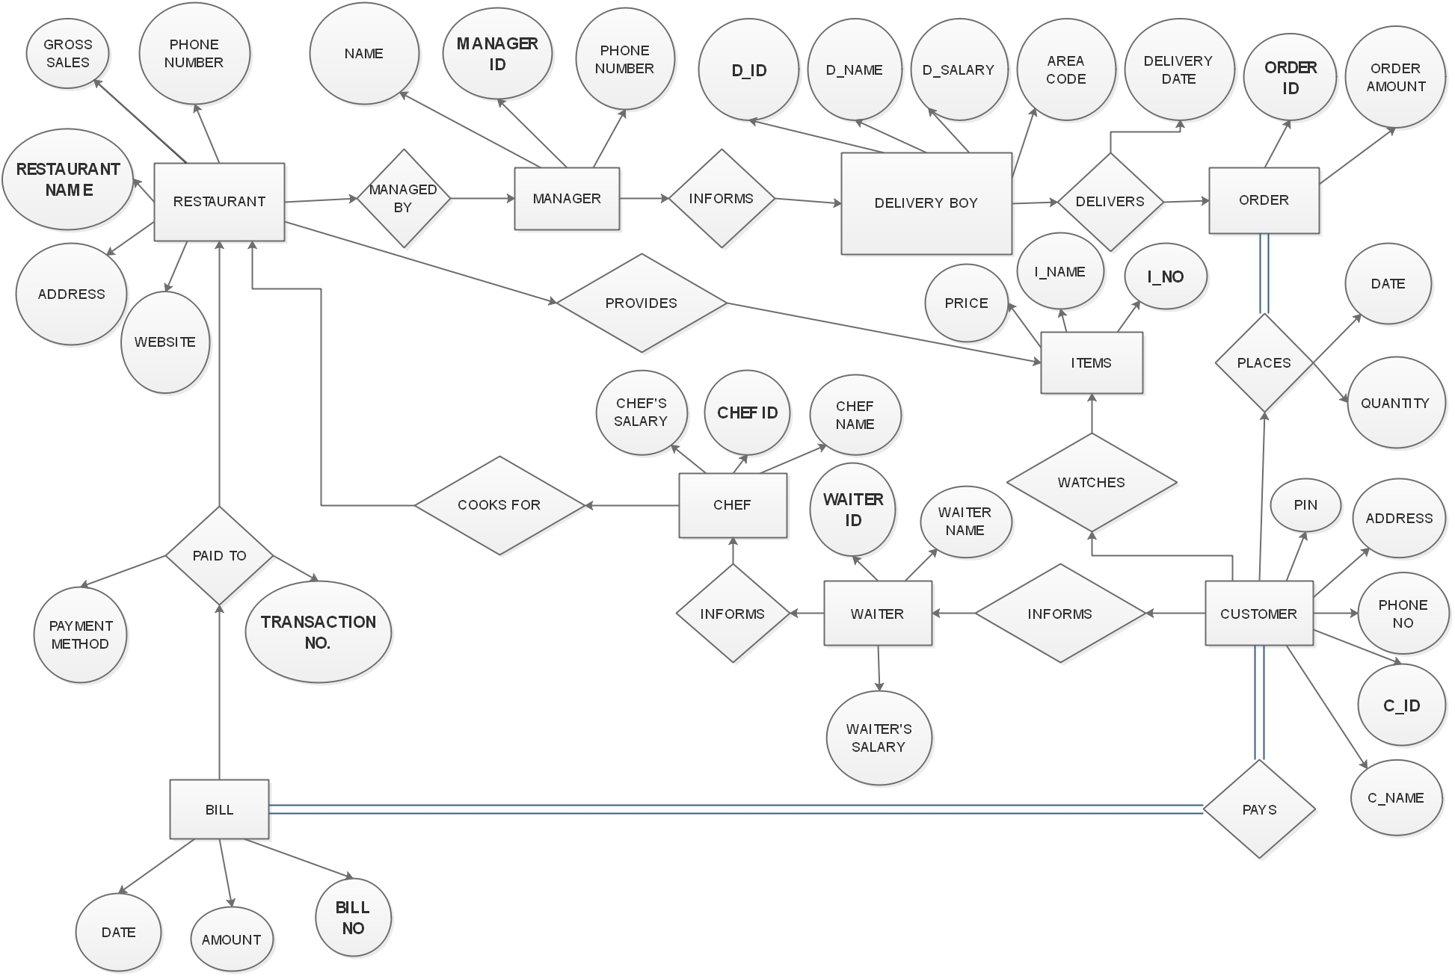

**Relational Schema:**

* **Restaurant** (Restaurant name, Phone number, Gross sale, Address, Website)
* **Manager** (Manager ID, Phone number, Name)
* **Delivery Boy** (D_ID, D_name, D_salary, Area code)
* **Order** (Order ID, Order amount)
* **Item** (I_No, I_name, Price)
* **Customer** (C_ID, C_name, PIN, Address, Phone no. )
* **Waiter** (Waiter_ID, Waiter name, Waiter’s salary)
* **Chef** (Chef ID, Chef’s salary, Chef name)
* **Bill** (Bill no, Date, Amount)
* **PaidTo** (Bill_no, payment_method, transaction_no)